Microsoft account

[Company name]

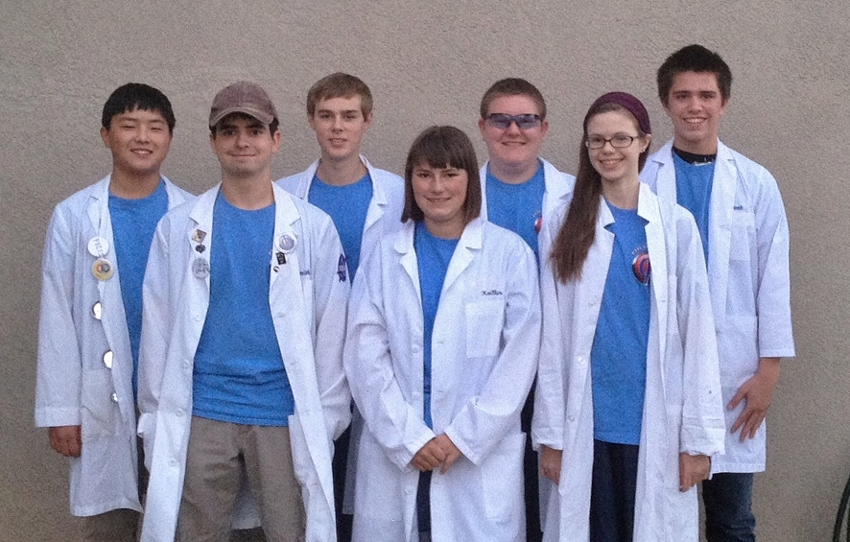

PHI Ω ENGINEERING NOTEBOOK

BIOS

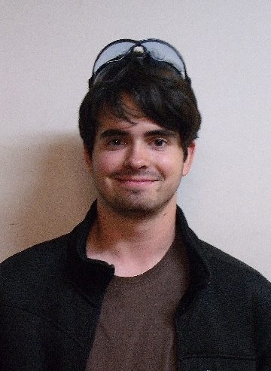

Jonathan Lokos 4th year on team

FAVORITE JOB ON TEAM: Team lead, hardware, 3D modeling, and driving.

HOBBIES: Robotics, airsoft, SCUBA diving, kayaking, and hiking.

INTERESTING FACTS: I am known in the robotics community as the “Beard of Knowledge”. I have been building and designing since I was three years old.

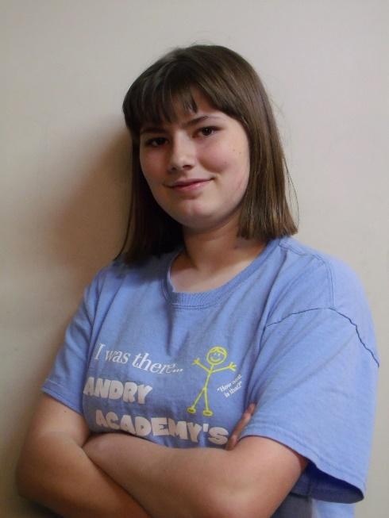

Kaitlin Cox 3rd year on team

FAVORITE JOB ON TEAM: Driving the robot and working in the notebook, as well as learning to write basic software

HOBBIES: Creative writing- particularly medieval fantasy stories and fanfiction- art, computer programming and game design, and roleplaying

INTERESTING FACTS: Over the course of the 2013/2014 school year I wrote the rough draft for a novel that is more than 110,000 words in length. I am currently editing the manuscript. I am also attempting to make a computer game using the Construct 2 platform. I am a keraunomaniac, which means I have an abnormal obsession with lightning. Not everything I say is meant to be taken literally.

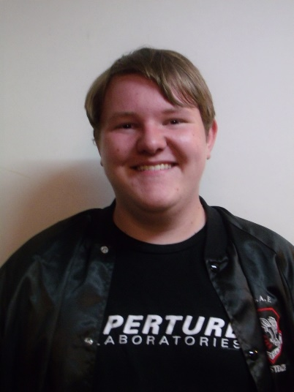

Eddie Pierce 3rd year on team

FAVORITE JOB ON TEAM: Hardware design, LabView programming

HOBBIES: Playing clarinet, PC gaming, novel writing, sketching, airsofting

INTERESTING FACTS: I have been known on the team as the designated target for all robots. For my first year on the team, I was called the Dementor, but that has since changed to Bones.

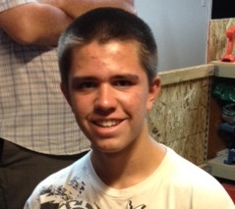

Noah Killian 2nd year on team

FAVORITE JOB ON TEAM: Software

HOBBIES: Programming, Cubing, League of Legends, Electronics

INTERESTING FACT: I’m too lazy to procrastinate so I’ll procrastinate later.

Holly Creech 1st year on team

FAVORITE JOB ON TEAM: Working on the notebook, and learning hardware.

HOBBIES: Playing the piano, teaching the piano, and writing.

INTERESTING FACTS: I love owls, chocolate, listening to music, and spending time with friends.



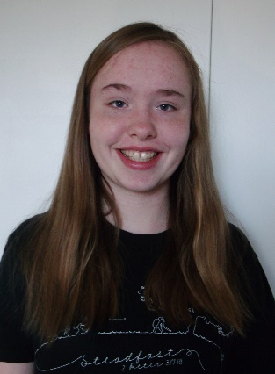

Hanna Creech 1st year on team

FAVORITE JOB ON TEAM: Hardware

HOBBIES: Photography, Baking, Piano (music), Swimming, And Drawing

INTERESTING FACTS: I enjoy my pets especially my dog and guinea pig. I’ve been doing piano for over 6 years and the flute for 1. My favorite color is blue.

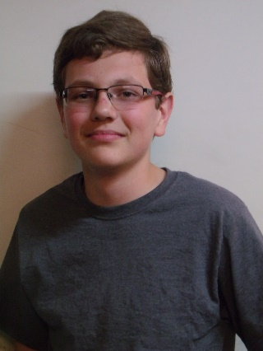

Sergei Cox 1st year on team

FAVORITE JOB ON TEAM: Hardware

HOBBIES: Softball, building things, reading.

INTERESTING FACTS: People call me different things and say my name wrong. I’m the weirdest person I know.

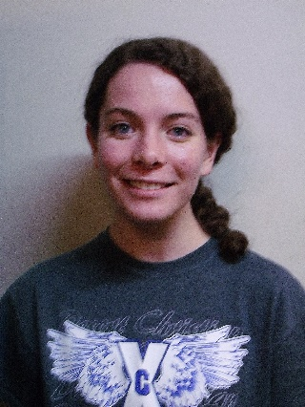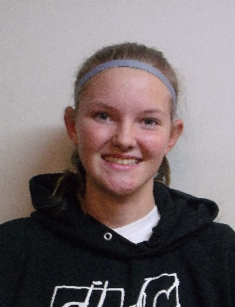

Anna Leland 1st year on team

FAVORITE JOB ON TEAM: Hardware

HOBBIES: Running Hurdles, Reading, SCUBA Diving, Script Writing

INTERESTING FACTS: I manage my school’s Cross Country Team and I’ve directed my school’s play for the past three years.

Becky Pierce 1st year on team

FAVORITE JOB ON TEAM: Software

HOBBIES: Playing volleyball and softball, running cross country and track, baking, piano

INTERESTING FACTS: I’ve been homeschooled my whole life. I helped start an FLL team in 2011. I used to be on a bowling team. I hate looking for nonexistent screws. I love the Dodgers.

MEETING LOG

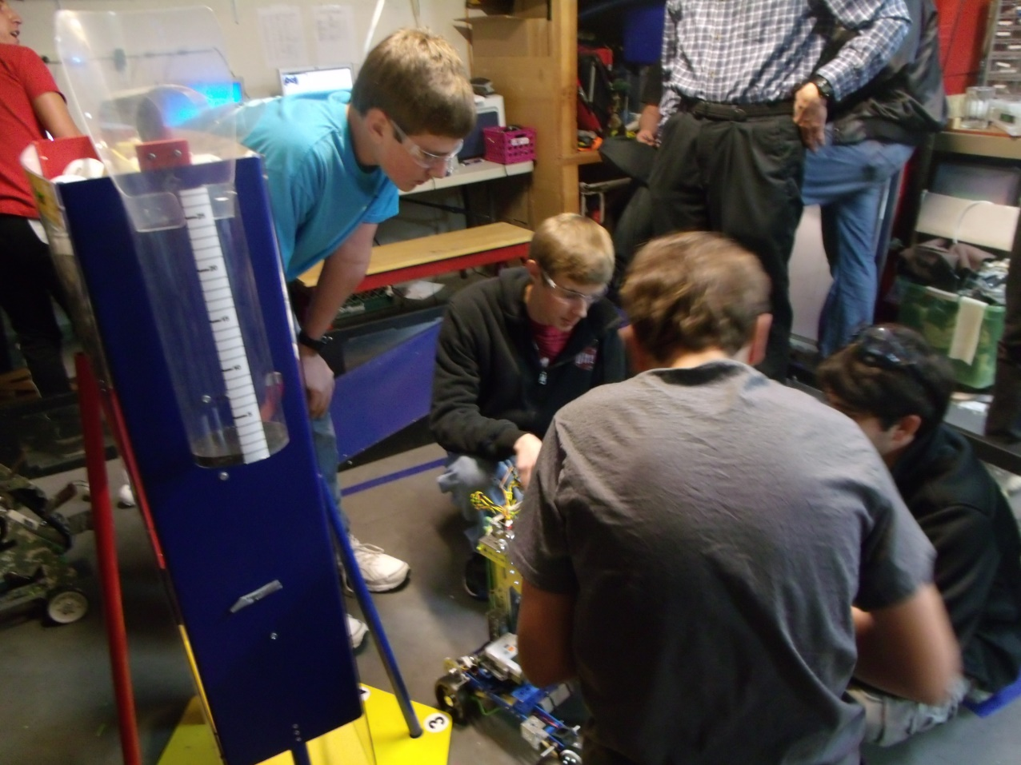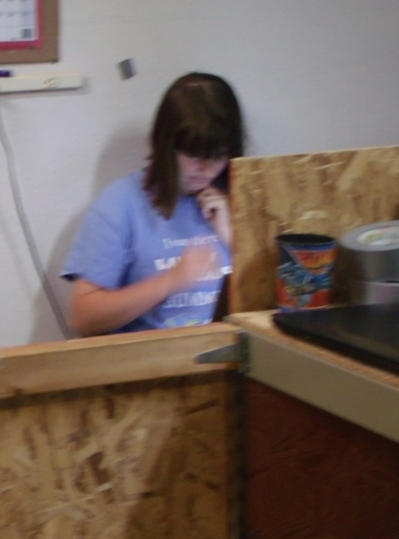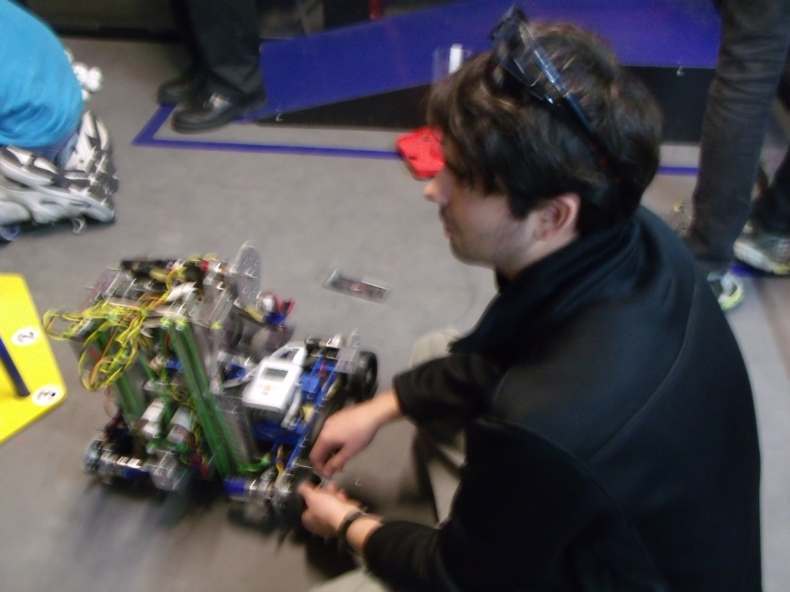

|  |
| --- |
| SAMPLE MEETING LOG- MM/DD/YYYY |
| HARDWARE  *Author initials* |
| SOFTWARE  *Author initials* |
| NOTEBOOK AND/OR OUTREACH  *Author initials* |

|  |
| --- |
| MEETING LOG- 9/8/2014 |
| HARDWARE  *HMC*  We prototyped a design that used a long, tube-like, mechanism with spinning blades to pull the whiffle balls into the robot. The purpose, and goal, is to collect both the large and small balls. We got as far as cutting out four pieces of cardboard, approximately 4” by 14”, and, using our BLUE duct-tape, we stuck it length-wise across the outer and inner sides of the cardboard to form a pillar. |
| SOFTWARE  *NK*  Our goals for tonight were to give some of the freshmen an intro to programming in RobotC which is the language our team uses.  Tonight we explained the basics of RobotC to the freshmen interested in learning it. We explained pragmas, includes, and basic motor controls. |

|  |
| --- |
| MEETING LOG- 9/11/2014 |
| HARDWARE  *JL*  Our goals for tonight were to rebuild both of our 2013-2014 chassis so we could mount prototypes and test them. We also wanted to brainstorm further ideas for ground intake systems.  Tonight we accomplished rebuilding and wiring both robots. We succeeded at mounting some prototypes on one of the robots and the freshmen learned how to program the other. We familiarized some of the freshmen with parts of the TETRIX kit. We also brainstormed an inverted funnel for scoring balls in the tubes. |
| *SOFTWARE*  *JM*  We further instructed freshmen on programming, teaching them about pragmas, how to control the motors, and how to create autonomies. We also explained basic C syntax. |
| NOTEBOOK  *KC*  Tonight we set up a syncing application to allow us to sync important files such as the Engineering Notebook, code files, and pictures between computers. We also set up a new, more detailed format for the meeting log. |

|  |
| --- |
| MEETING LOG- 9/15/2014 |
| HARDWARE  *MK*  Our goals for this meeting were to further our designs for collecting the balls. We also wanted to brain storm and come up with new designs for lifting and scoring the balls.  We improved a conveyer belt-like design for collecting the balls. It has cardboard paddles on it that are slightly u-shaped and are designed to scoop up the balls and drop them into the bucket. This bucket is attached to a drawer slider which is used to lift it. |
| SOFTWARE  *NK*  We continued to work with the freshmen and their coding skills. As they learn more, they will be in charge of the very basic autonomies and tele-ops while those of us that are more experienced will work with the more advanced concepts. |

|  |
| --- |
| MEETING LOG- 9/18/2014 |
| HARDWARE  *SC*  We wanted to finish our prototypes, make more prototypes, and build our game field.  The main prototype that we have been working on is a conveyor belt that picks up balls and carries it up into a bucket. The bucket is mounted on a linear slide that carries it with the balls to the height of rolling goals. We also made a smaller tube that is around the conveyor belt to help both ball sizes go up through it into a bucket and extended the width of the flaps of card board so that the conveyor belt could pick up both sizes of balls, and made a bucket to hold the balls to score them into the goals. In addition to this, we prototyped some ideas for grabbing the rolling goals. |
| SOFTWARE  *JM*  We discussed finding distance from acceleration and finding distance from IR sensor values. We were theorizing ways to use double integration so that we would be able to ascertain accurate distances from the accelerometer and are now trying to find equations that will allow us to do so. Unfortunately, double integration can greatly multiply error so we need to find a way to make measurements as accurate as possible. We are also theorizing ways we can find distance with IR finding the angles we are from the IR emitter and then using trigonometry to find our relative position. |

|  |
| --- |
| MEETING LOG- 9/22/2014 |
| HARDWARE  *CS*  Tonight we finished off the field build by assembling the last parts of the ramp, and adding the tapped lines to the floor to mark off the specified zones/goals.  Our first prototype was a small “L” shaped piece designed with a bendable edge that would fit on the back of the robot. The robot would drive backwards bending the edge to snap onto the rolling goals, and then proceed to drive to the scoring zone. This piece could also be modified with a servo to allow it to be raised/lowered onto the rolling goal lip.  Our next prototype we fitted onto a square-bot to get a better look at it. It consisted of a conveyor belt fitted to raise the whiffle balls into a holding container. Once the container was filled, an arm would proceed to raise the container, and dump the balls into whatever rolling goal was desired.  Our third prototype for the night still needs some work. It is designed to be a tube that will pull in the whiffle balls using foam prongs attached to motors. A sensor will count the amount pulled in, and will stop the mechanism at the desired amount. After this, the robot will be driven up to a rolling goal, and the balls will be deposited out of a “U” shaped piece at the top of the container. In order for this design to work, we still need NASA to cut out certain sections of the tube, and supply additional parts.  Our final design for the night consisted of an arm, holding area, and an elevator. We designed an arm to catch balls, and put them into a sloped holding container. The balls would all roll to the corner where an oval shaped conveyor would scoop the balls out, flip over, and dump them into a desired container on their “O” shaped path. |
| SOFTWARE  *Author initials* |

|  |
| --- |
| MEETING LOG- 9/25/2014 |
| HARDWARE  *CPB*  We built some prototypes tonight. One of the prototypes we built was a little box hand that helps us pick up balls. It’s workable and easy to operate. Another prototype that we did was, attach a second linear slide for extra height. We finished wiring the bot and finished building the shield around the conveyor belt, to contain the balls when we pick them up. We also created a funnel to help guide the balls into conveyor belt. |
| SOFTWARE  *NK*  We are looking at the various ways to perform a double integration on our accelerometer values to determine distance travelled while minimizing error. Some of the methods we have encountered are Simpson’s Rule, Trapezoidal integration, rectangular integration, and Boole’s rule. Trapezoidal appears to be the one we will use. |

|  |
| --- |
| MEETING LOG- 9/29/2014 |
| HARDWARE  *HRC*  Tonight we worked on prototypes. One of the prototypes we worked on is a bucket. The bucket is lifted by a linear slide. The purpose of the bucket is for the balls to drop into it and for it then (using the linear slide) to take the balls up and drop them into the scoring goals. The bucket can also tip for more accurate and more consistent scoring. Another prototype we worked on is a way to pick up balls. It uses zip ties and no slip grip in a rectangular box. We also discovered some things we could work more on to improve. |
| SOFTWARE  *Author initials* |

|  |
| --- |
| MEETING LOG- 10/2/2014 |
| HARDWARE  *HRC*  *We started to build our robot tonight and apply some of the ideas we had come up with. The main thing we did tonight though, was wire the robot. We also worked on some new prototypes. An example of what we prototyped tonight was a way to clasp to the bottom of the rolling goals. Another example is a way to intake balls.* |
| SOFTWARE  *Author initials* |

|  |
| --- |
| MEETING LOG- 10/6/2014 |
| HARDWARE  *EP*  Tonight, Phi Alpha and Omega opened in prayer together, then each team discussed what they would work to accomplish during the meeting. After settling what each of the team members was working on, the teams split ways to work towards their individual goals. The meeting’s work got started with an in-depth stress test of the 3D printed plastic nacelles for Khan’s chassis. A small group constructed a simple mount for a small video camera one team member owns. After the mount was completed, it was mounted to the robot in a position such that the camera could watch the springing motions of the nacelle. After several short drops off the side of the ramp, one of the front nacelles broke in two. Through detailed examination, we observed that the plastic sheared from front to back, a place in which we were warned that shearing could occur if put under stress. Fortunately, we had a spare on hand and the nacelle was quickly replaced. After thinking of a fix to this problem, we accessed the computer model for the part and increased the thickness of the walls by three. Then the new part model was sent to our 3D printer contact for construction. Soon after, we discovered the other front nacelle was developing a crack as well. The chassis was set to the side until we could get the better replacement parts and the group that was working on the chassis turned to other projects.  During the stress testing, a separate group of Phi Omega members was working another prototype for scoring. This prototype is a large bucket with two brushes on the top for intaking the balls. Then it would dump the balls out the back of the bucket. The brushes were recycled from a previous scoring system from the previous year’s challenge.  One set of team members that moved from the chassis of the robot began reworking another of the few prototypes we have. The “Da Vinci” had a major redesign and the paddle-like intake mechanism was disassembled to later be replaced with a belt system. The rest of the team members that were previously working on the chassis helped Phi Alpha with their robot.  Shortly before the meeting ended, we stopped building to clean up the mess we had made. Then we had a short debrief detailing what each group had accomplished. Finally, the meeting was ended with prayer. |
| SOFTWARE  *Author initials* |

|  |
| --- |
| MEETING LOG- 10/9/2014 |
| HARDWARE  *KC*  Today we repaired the wheel system with new 3d-printed parts after we discovered that the original models were prone to cracking when subjected to stress. We also worked on the intake tube, and began work on the arm that will lift it. We have been working on a three-stage arm that remains parallel to the ground as it raises that, when completed, should be able to reach the highest goals. |
| SOFTWARE  *Author initials* |

3

|  |
| --- |
| MEETING LOG- 10/13/2014 |
| HARDWARE  *HMC*  Tonight our team mounted the arm structures onto our robot, and worked on our ball intake brush system. Although they both still need some work, we have made progress. Some of the seniors worked with our team to locate parts from past years that we could recycle and work into this year’s robot. We continued perfecting the video, and continued to work on setting up this year’s notebook. At the end of the night we were all able to view the stage of the video we were at, as a group. |
| SOFTWARE  *Author initials* |

|  |
| --- |
| MEETING LOG- 10/16/2014 |
| HARDWARE  *SC*  We made some chain and cut metal for the three joint arm. We also drilled the holes that the chain gear runs on and geared it to power the arm. Then when we tried to assemble it. We found that the length between the gears that the chain runs on was either too long or too short, so we marked where the gear would need to go by holding the chain on the gear and marking it. Then we drilled the holes and tried to mirror that on the other pieces of metal. |
| SOFTWARE  *Author initials* |

|  |
| --- |
| MEETING LOG- 10/20/2014 |
| HARDWARE  *Author initials* |
| SOFTWARE  *Author initials* |
| NOTEBOOK AND/OR OUTREACH  *Author initials* |

|  |
| --- |
| MEETING LOG- 10/23/2014 |
| HARDWARE  *Author initials* |
| SOFTWARE  *Author initials* |
| NOTEBOOK AND/OR OUTREACH  *Author initials* |

|  |
| --- |
| MEETING LOG- 10/27/2014 |
| HARDWARE  *HRC*  This week we spent a lot of time preparing for our yard sale. Some of us made signs to advertise it. We scheduled each person’s shift for the yard sale so that there wouldn’t be shifts without enough workers and vice versa. The team worked to complete the final hardware implementation. Also, we developed some autonomy programs. |
| SOFTWARE  *Author initials* |
| NOTEBOOK AND/OR OUTREACH  *Author initials* |

|  |
| --- |
| MEETING LOG- 10/30/2014 |
| HARDWARE  *SMC*  Our goal was to put motors on both sides of the arm. With one arm we didn’t have enough power to lift the arm up. We worked on the three joint arm and were trying to figure out how to make the robot fit into dimensions. One of the motors stuck out of the dimensions and we couldn’t flip it around. We needed to gear it so that we would get enough torch so that we don’t burn out the motors. We found that our idea was too complicated and decided to work on a new idea. |
| SOFTWARE  *Author initials* |
| NOTEBOOK AND/OR OUTREACH  *Author initials* |

|  |
| --- |
| MEETING LOG- 11/3/2014 |
| HARDWARE  *BP*  We changed the three joint arm to be sliders. The reason was because it was a simpler design and we could have the bot ready in for competition. We installed the winch to the back of the robot to make the slider arms go up. We also made a few tweaks to the ball intake to make it so both balls can easily be fed into the tube. After that, we wired the bot and checked all the wiring to make sure it was clean and acceptable. |
| SOFTWARE  *Author initials* |

|  |
| --- |
| MEETING LOG- 11/6/2014 |
| HARDWARE  *HRC*  On Monday we put a servo on the tube that opens and closes to let the balls out. Later that evening we re-wired most of the robot again so that it can work and run more smoothly. Also, we attempted wiring the arm, making sure it could reach to the top of the linear slides. We put on a Samantha, mounted an NXT, and placed the Battery on the robot. We tweaked around to improve the overall design. |
| SOFTWARE  *Author initials* |
| NOTEBOOK AND/OR OUTREACH  *Author initials* |

|  |
| --- |
| MEETING LOG- 11/10/2014 |
| HARDWARE  *S.C.*  Our goals were to finish wiring our robot, do drivers practice and to put a servo on our tube that flips and scores the balls. We needed a long wire to run up our linear slide but we didn’t have the wire we needed. So we put a couple braces to stabilize the linear slide and we wired our winch that lifted the slide. We thought that it would be good to have another robot so that some of the new people could practice traveling around and playing defense so we built another square robot. The square robot is just a simple chassis that is run by two motors and some chain. The last thing we did was to test the individual units and make tweaks to it. |
| SOFTWARE  *Author initials* |
| NOTEBOOK AND/OR OUTREACH  *Author initials* |

|  |
| --- |
| MEETING LOG- 11/13/2014 |
| HARDWARE  *Author initials* |
| SOFTWARE  *Author initials* |
| NOTEBOOK AND/OR OUTREACH  *Author initials* |

|  |
| --- |
| MEETING LOG- 11/17/2014 |
| HARDWARE  *Author initials* |
| SOFTWARE  *BP*  Once upon a time we made a basic autonomy. After killing the dragon, we mapped out the field and wrote some notes explaining exactly what we wanted to do. Since the princess was safely returned to her garage, we brought up a Teleop and had some of the newbies drive our bug-bot. Now reunited with his one true love, Khan and the princess drove happily ever after… |
| NOTEBOOK AND/OR OUTREACH  *Author initials* |

|  |
| --- |
| MEETING LOG- 11/20/2014 |
| HARDWARE  *Author initials* |
| SOFTWARE  *Author initials* |
| NOTEBOOK AND/OR OUTREACH  *Author initials* |

|  |
| --- |
| MEETING LOG- 11/24/2014 |
| HARDWARE  *HRC*  Tonight, we changed our conveyer belt. Our new conveyer belt has chain with nails instead of pins. There are two nails every four inches that are secured on by electrical tape. On the nails we put foam paddles. The paddles are a T shape. |
| SOFTWARE  *Author initials* |
| NOTEBOOK AND/OR OUTREACH  *Author initials* |

|  |
| --- |
| MEETING LOG- 11/27/2014 |
| HARDWARE |
| SOFTWARE  *Author initials* |
| NOTEBOOK AND/OR OUTREACH  *Author initials* |

|  |
| --- |
| MEETING LOG- 12/1/2014 |
| HARDWARE  *Author initials* |
| SOFTWARE  *Author initials* |
| NOTEBOOK AND/OR OUTREACH  *Author initials* |

|  |
| --- |
| MEETING LOG- 12/4/2014 |
| HARDWARE  *Author initials* |
| SOFTWARE  *Author initials* |
| NOTEBOOK AND/OR OUTREACH  *Author initials* |

|  |
| --- |
| MEETING LOG- 12/8/2014 |
| HARDWARE  HRC  After several of Omega’s team members attended Phi Alpha’s competition and we saw problems that where regularly occurring with other teams robots so we decide to re-design our robot. Tonight we took the tube off Khan and built prototypes for our new design. Our new design is going to have chain on the wheels. It is going to use several brush to take in the balls and up to a bucket. The bucket is then going to be lifted to the appropriate height by three linear slides. The slides will all be on one side. We also got to do some practice driving. |
| SOFTWARE  *Author initials* |
| NOTEBOOK AND/OR OUTREACH  *Author initials* |

|  |
| --- |
| MEETING LOG- 12/11/2014 |
| HARDWARE  *HRC*  *Tonight, we started working on our new design. We measured and cut out the plastic for our new bucket using a dremel, then we assembled it. The linear slides where taken off, disassembled, and reassembled to be three on one side verses two on both sides. Also, We put on the brushes using zip ties.* |
| SOFTWARE  *Author initials* |
| NOTEBOOK AND/OR OUTREACH  *Author initials* |

|  |
| --- |
| MEETING LOG- 12/15/2014 |
| HARDWARE  *KC*  Tonight we continued to work on our hardware revisions. Our design now uses a scoop in the front and works much like a vacuum cleaner without the suction. It has a brush made of zip ties in the front that rotates and flicks balls back into a bucket, where they are stored. This bucket is independent of the scoop, and is attached to a drawer slider which lifts the bucket up. We plan to add a hook mechanism to the back of the robot as well to catch the base of the scoring tubes and hold them in a static position while the bucket dumps the balls in. |
| SOFTWARE  *Author initials* |
| NOTEBOOK AND/OR OUTREACH  *Author initials* |

|  |
| --- |
| MEETING LOG- 12/18/2014 |
| HARDWARE  *HMC*  Tonight we were able to mount the bucket onto our new robot design. We had to add supports to the bucket to stabilize it. We used a variety of tools to aid us in our work. We used a dremel to shorten an axel that was in the way, we used rivets to fasten the bucket together, we used the heat gun to melt and bend the plastic according to our needs, and we mounted the bucket with nuts and bolts onto our linear slide. We also fixed some issues we ran into with the linear slides, so, at the time being, they are functioning properly. |
| SOFTWARE  *Author initials* |
| NOTEBOOK AND/OR OUTREACH  *Author initials* |

|  |
| --- |
| MEETING LOG- 12/22/2014 |
| HARDWARE  *HMC*  Tonight we set the goal, to finish hardware on our robot. Although there will be modifications, we have our newest design almost completed. We met extra hours in order to keep on schedule as there will be no meeting on the 25th due to Christmas. Hardware included mounting the bucket, mounting the Samantha, sawing, drilling, and working with metal and plastic to build supports for servos. We intend to meet later in the week for driver practice. |
| SOFTWARE  *Author initials* |
| NOTEBOOK AND/OR OUTREACH  *Author initials* |

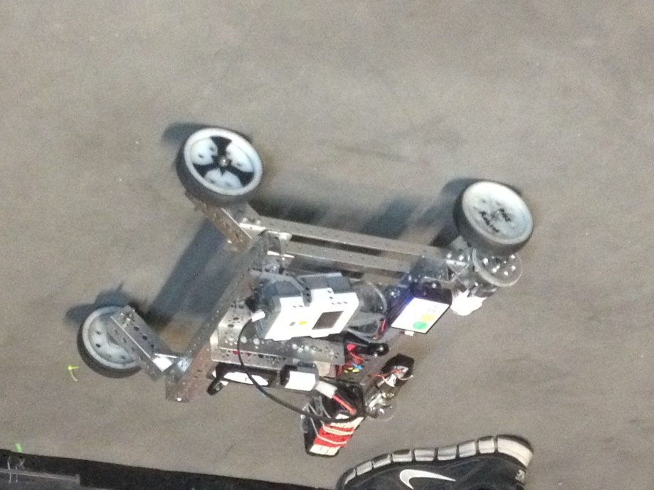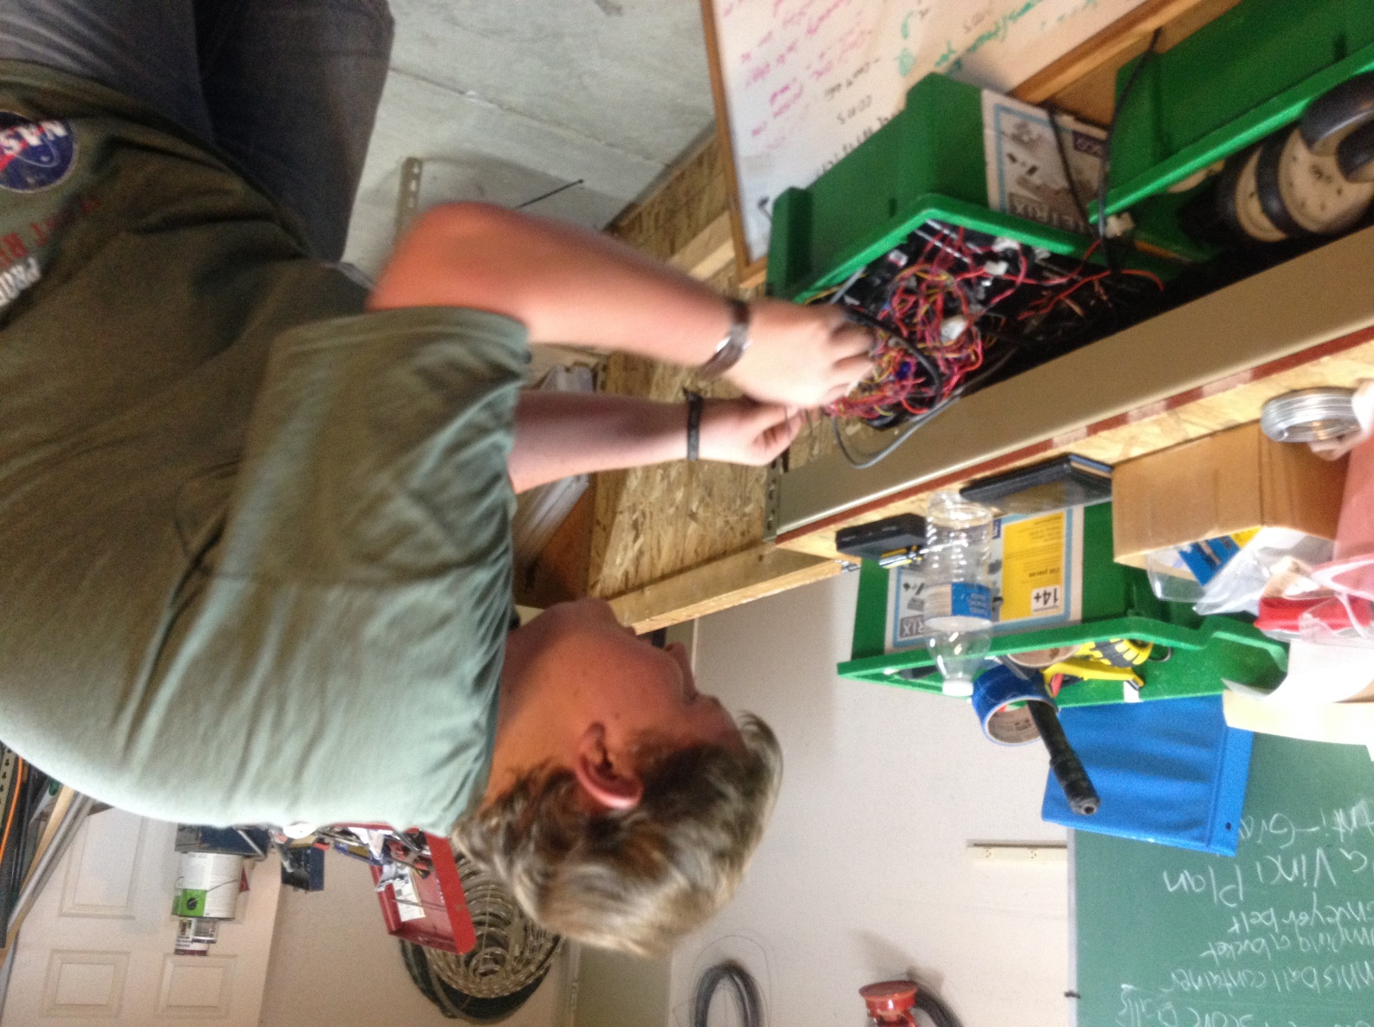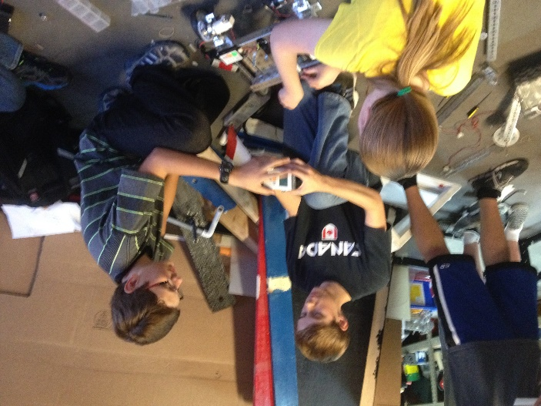

HARDWARE

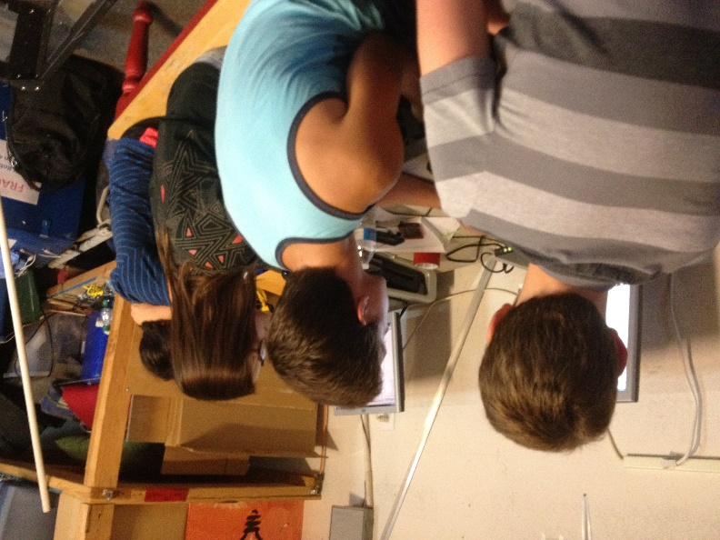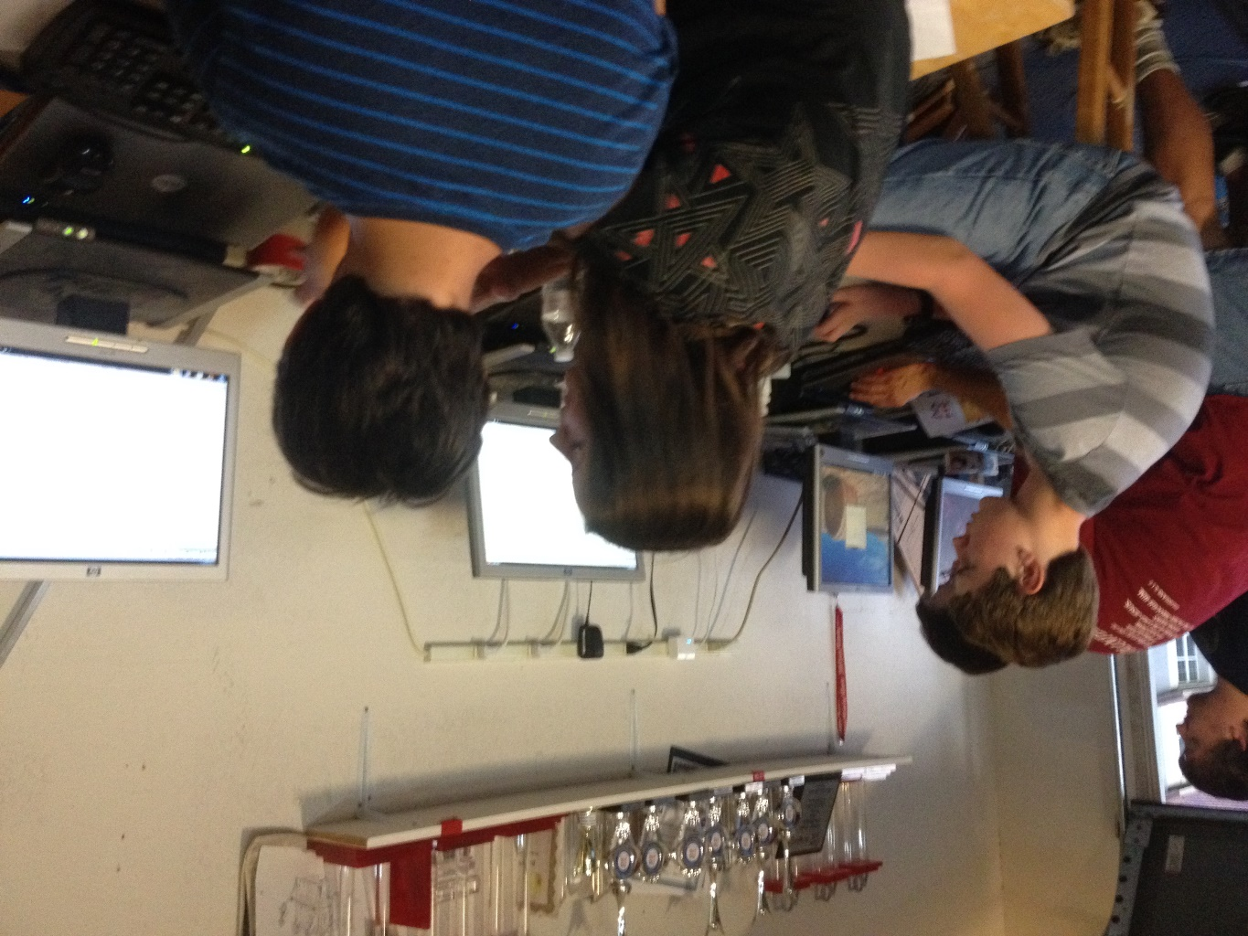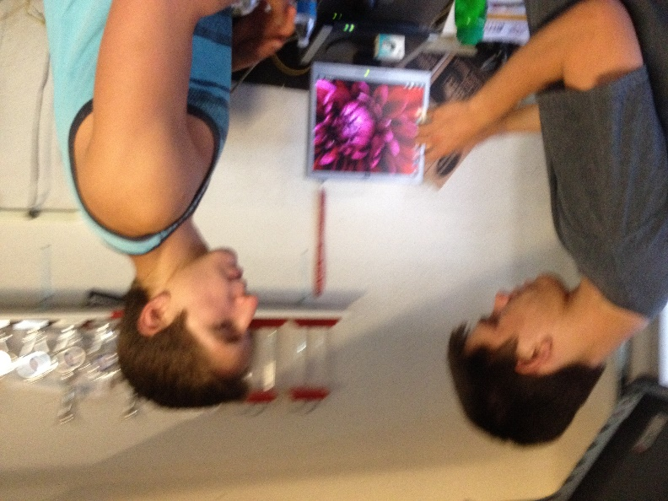

SOFTWARE

FUNDRAISING

Promote Award Video Entry:

TEAM ORGANIZATION

PROMOTE VIDEO

This year Phi Robotics decided to make an entry for the Promote Award. Both Phi Alpha and Phi Omega collaborated to make a video submission for the award. The teams came together and submitted their answers to this year’s challenge- Why I Chose FIRST. Then we compiled those answers and combined them into a 60-second video.

We wrote several drafts of the script we used for the video. The final draft is included below:

Person A - Why First?

Person B - Why First?

Person C - Why First?

Person D - Why First?

-Screen shows a collage of "Why First?"

- Screen shows a large "WHY FIRST?"

Luke - I chose FIRST because it's a way to learn new things ()

Kaitlin - to challenge ourselves ()

Hanna - to give us head starts to our futures ()

Mike - I chose FIRST because it builds teamwork and cooperation ()

Person B – It brings together new friends (Cole)

Person C – It provides a way to interact with others who share our interests (Sergei)

Person A -I chose FIRST because it teaches responsibility (Becky)

Person B – It teaches us to act independently and take initiative (Holly)

Person C – how to become both good leaders and good followers (Jonathan)

Person D – to learn to sacrifice for the good of others (Eddie)

Person E – to learn diligence, confidence, and determination (Holly)

Person F – and to become more creative (Cici)

Person A - I chose FIRST because it's a way to share gracious professionalism (Mike)

Person B - to encourage others (Scott)

Person C - to help others (Becky)

Person A - I chose FIRST because it's a way for us to reach out to the community (Kaitlin)

Person B - to participate in and host events (Kayla)

Person C - to partake in healthy competition (Hanna)

All- I chose FIRST because it’s a way to have fun!

*credits*